Solve each task using Redis:

1. Create a key, name. Value will be your first name.



1. Create a grade key with value 10. Decrease it by 1 first, then by 3.5 points.

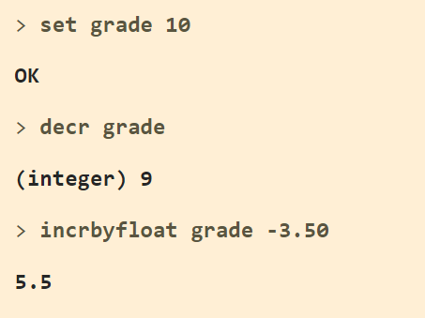

1. Update the key name with your full name validating that the key exists.

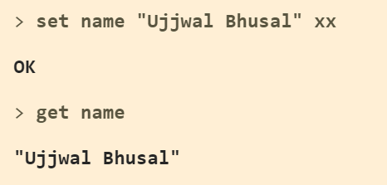

1. Set an expire time of 2 minutes (in milliseconds) for the key grade.

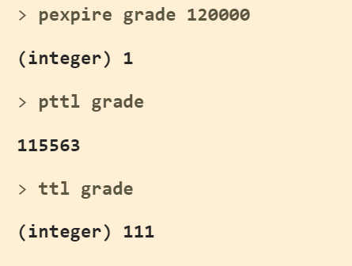

1. Delete the key name and then check if a key name exists.

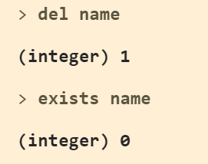

1. Create a list of 3 friends

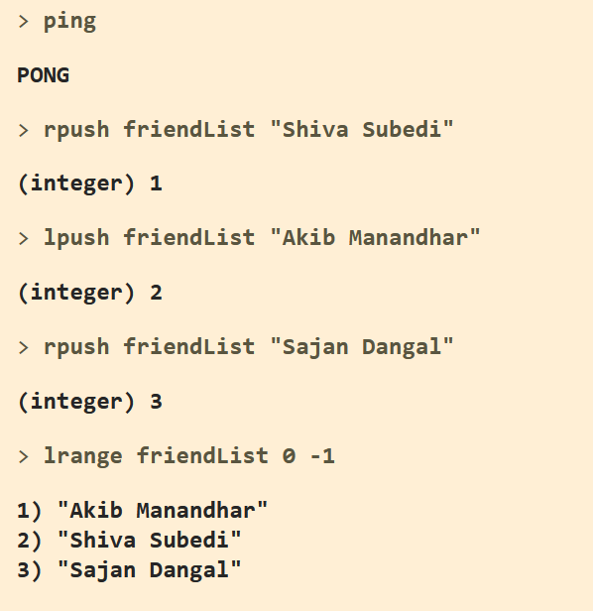

1. Remove the last element

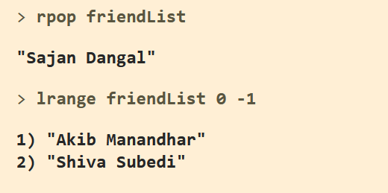

1. Add 2 friends at the end (tail) of the list

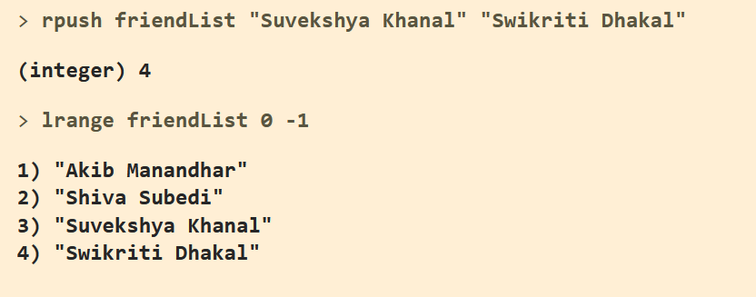

1. Remove the first element

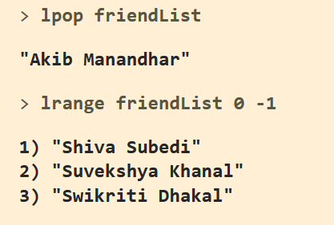

1. Add 2 more friends but this time at the beginning (head) of the list

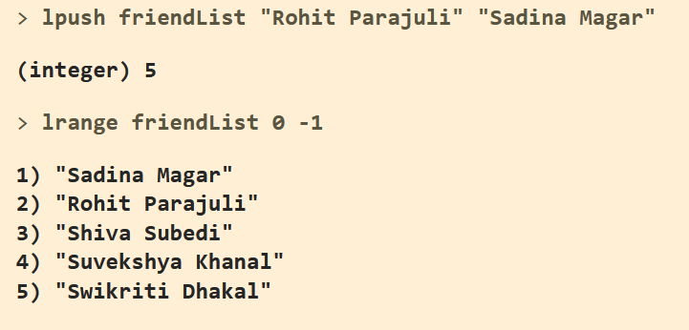

1. Trim the list so it contains only the first 3 elements

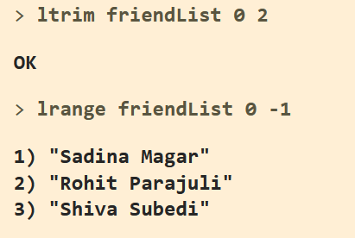

1. Create two sets: pets and animals. Add 4 elements to each set, with at least one common item in both sets.

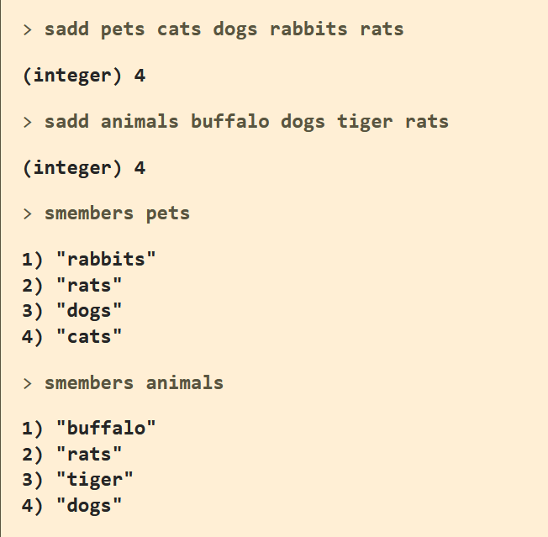

1. Verify if "cat" is member of the pets set

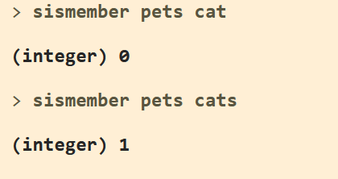

1. Get the common items between both sets

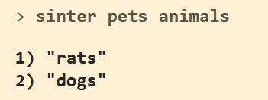

1. Create a new set which contains all elements from both sets (use a single command instead of manually adding each member to the new set)

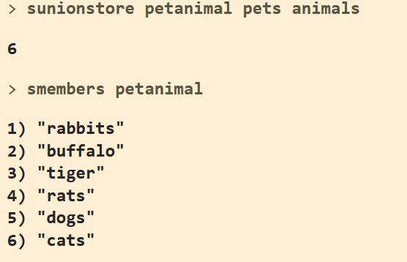

1. Get the animals that are not included in the pet set.

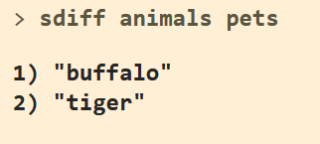

1. Retrieve 3 random animals (use a single command); the result can contain duplicate values.

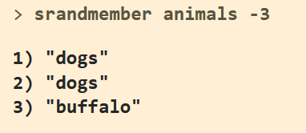

1. Create a hash that describes a country using 4 properties (you define them)

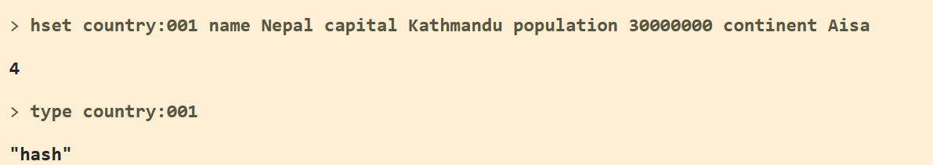

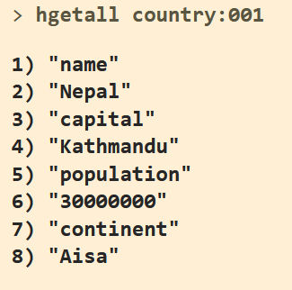

1. Retrieve the value of three properties: two of them exist in the hash while the other one doesn't.

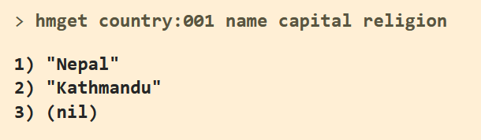

1. Create a sorted set with 5 movie names. The score will be a rating value that goes from 0 to 10 (you assign it).

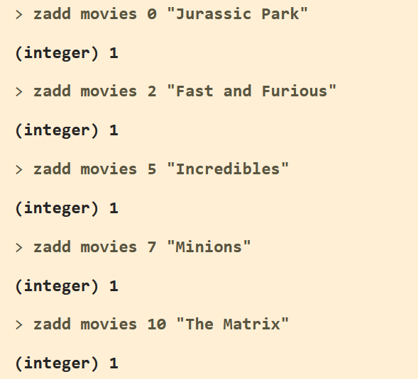

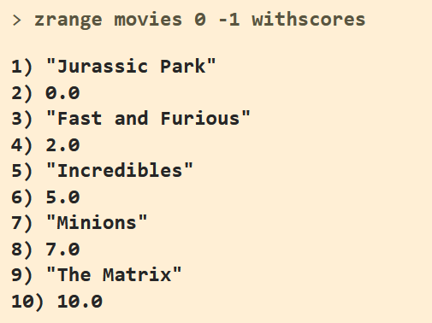

1. Get the movies with a score value of at least 8.0 points

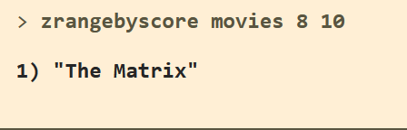

1. Discard all movies with score lower than (or equal to) 5.0 points

